WEB PROGRAMMING

MODUL PRAKTIKUM

DAFTAR ISI

4 HTML & Git 3

4.1 Introduction 3

4.1.1 JS Intro 3

4.1.2 Change Content 4

4.1.3 Change Style 5

4.1.4 Change CSS Class 6

4.1.5 JS In Head 7

4.1.6 JS In Body 8

4.1.7 JS From File 9

4.1.8 Browser’s Log 10

4.1.9 Multielement 11

4.2 Data Type 12

4.2.1 Number 12

4.2.2 String 13

4.2.3 Arithmetic 14

4.3 Syntax 15

4.3.1 For Loop 15

4.3.2 Array, In Loop 16

4.3.3 If Then Else 17

4.4 Object 18

4.4.1 Declaration 18

4.4.2 Creation 19

4.4.3 Method 20

4.4.4 Constructor 22

4.5 Invocation Pattern 24

4.5.1 Method Invocation 1 24

4.5.2 Method Invocation 2 25

4.5.3 Function Invocation 1 27

4.5.4 Function Invocation 2 28

4.5.5 Constructor Invocation 1 29

4.5.6 Constructor Invocation 2 30

4.5.7 Apply Invocation 31

# HTML & Git

## Introduction

### JS Intro

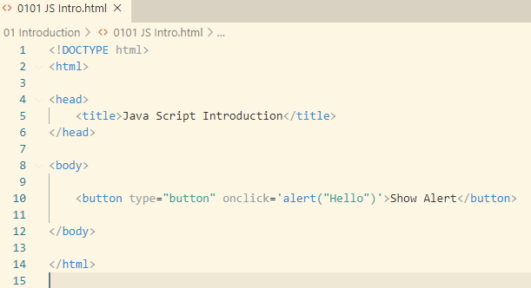

### Change Content

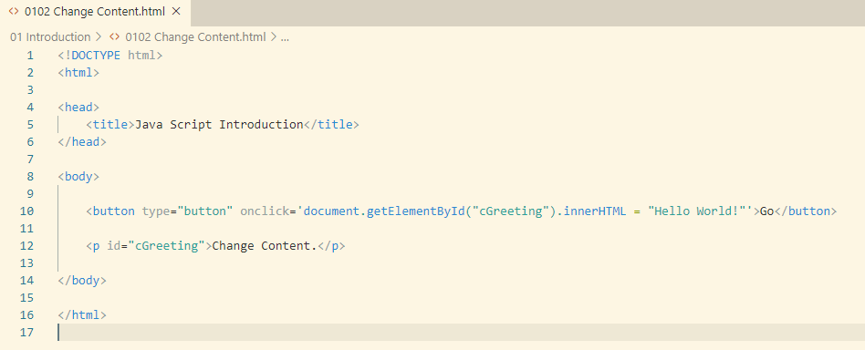

### Change Style

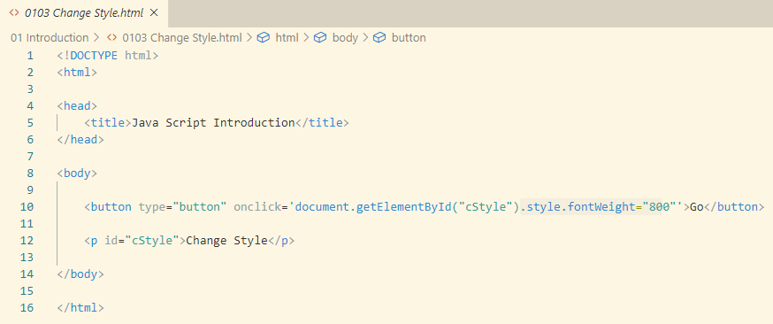

### Change CSS Class

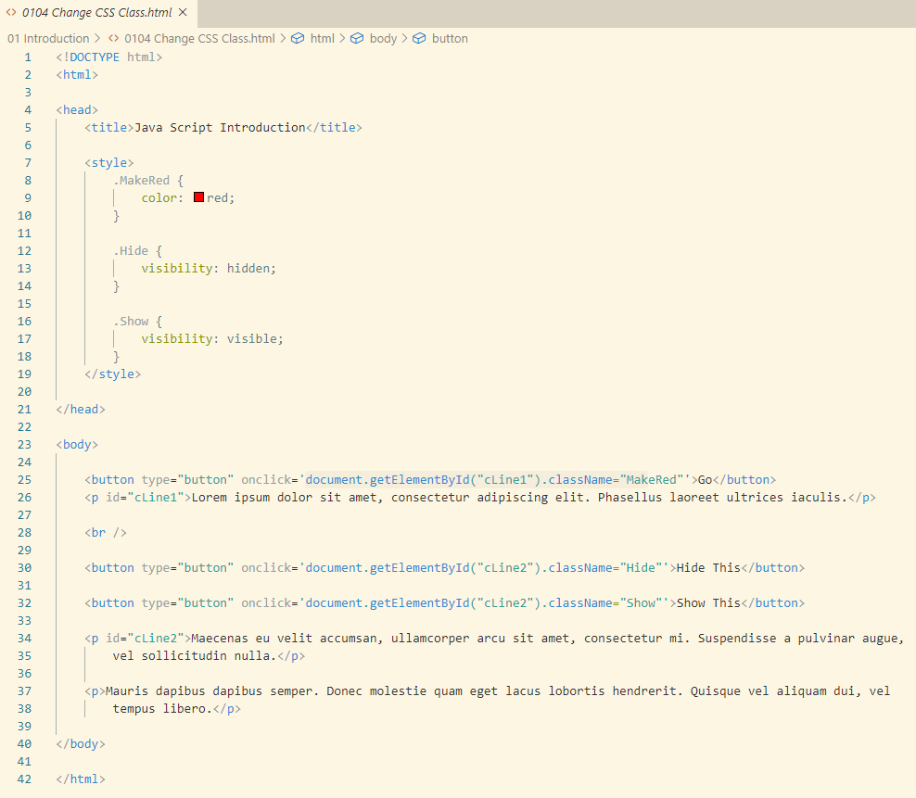

### JS In Head

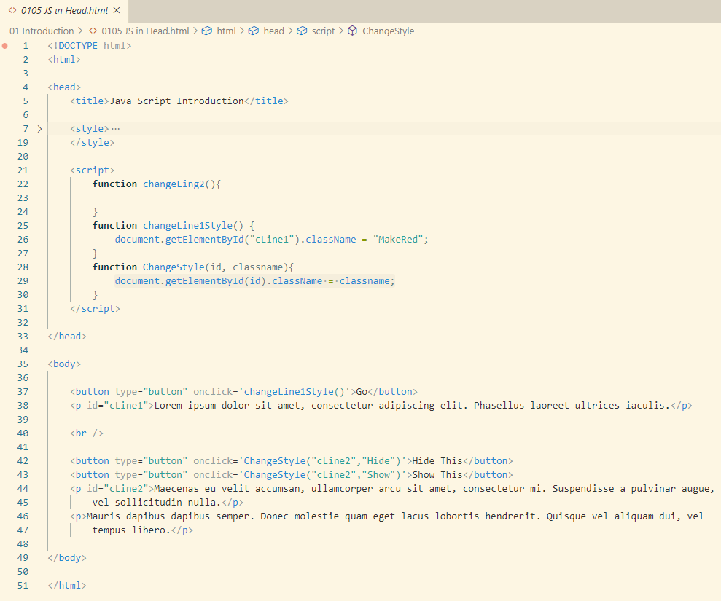

### JS In Body

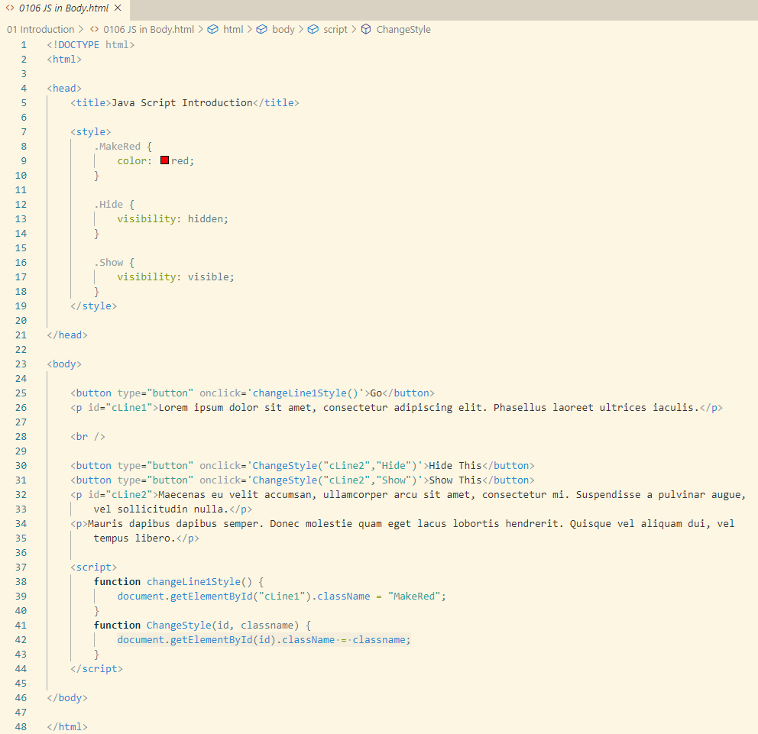

### JS From File

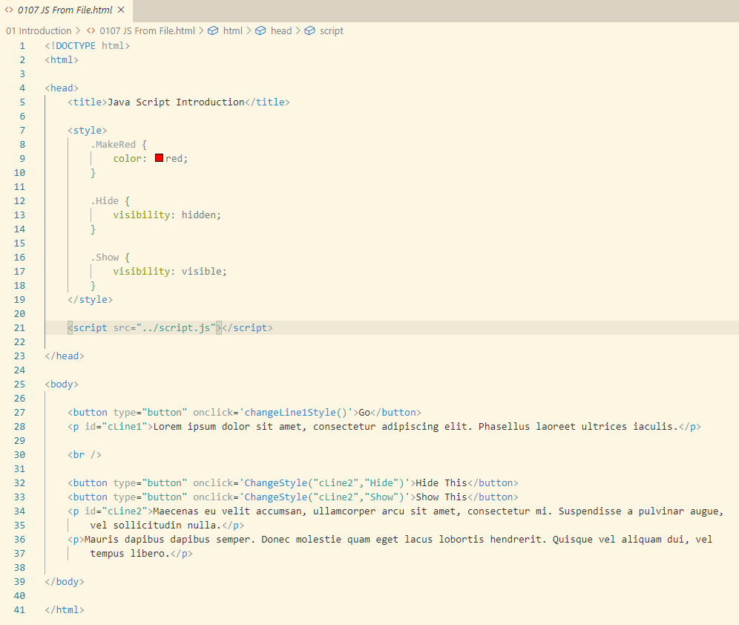

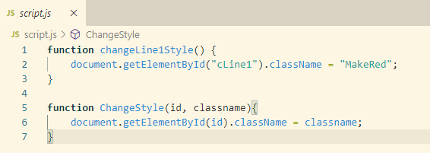

### Browser’s Log

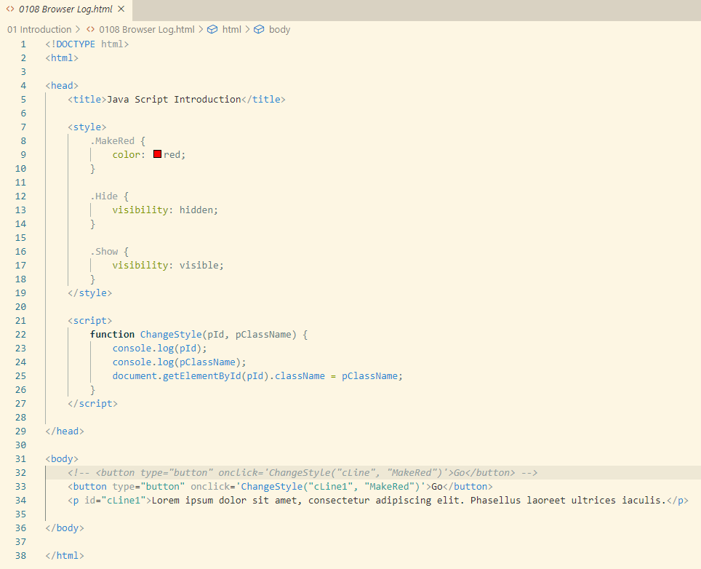

### Multielement

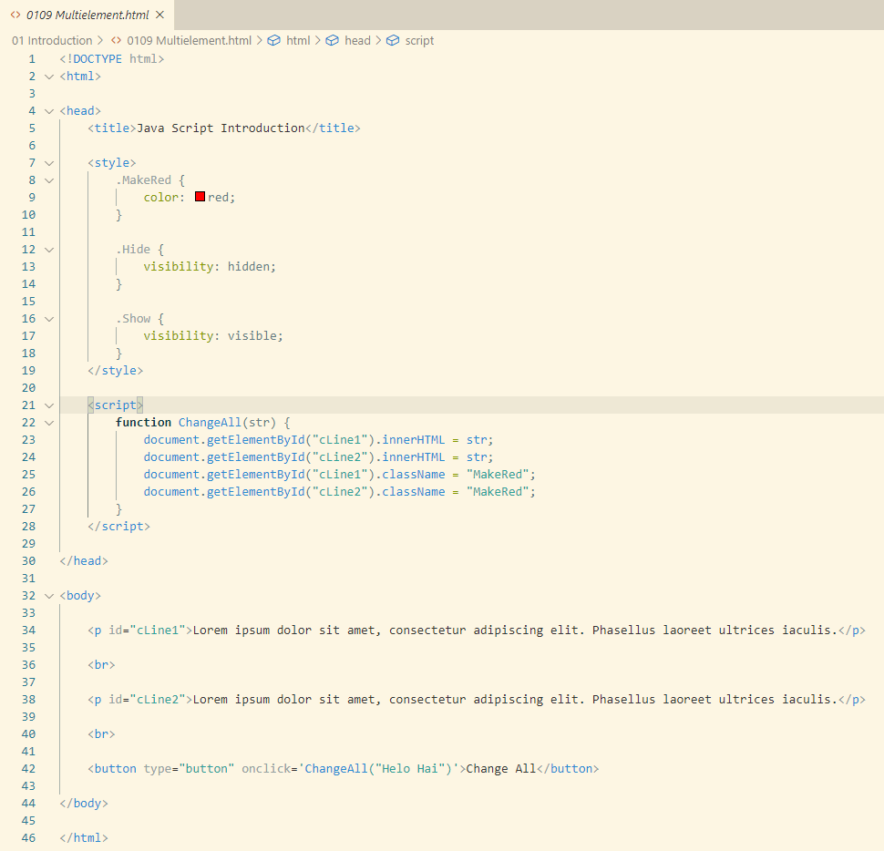

## Data Type

### Number

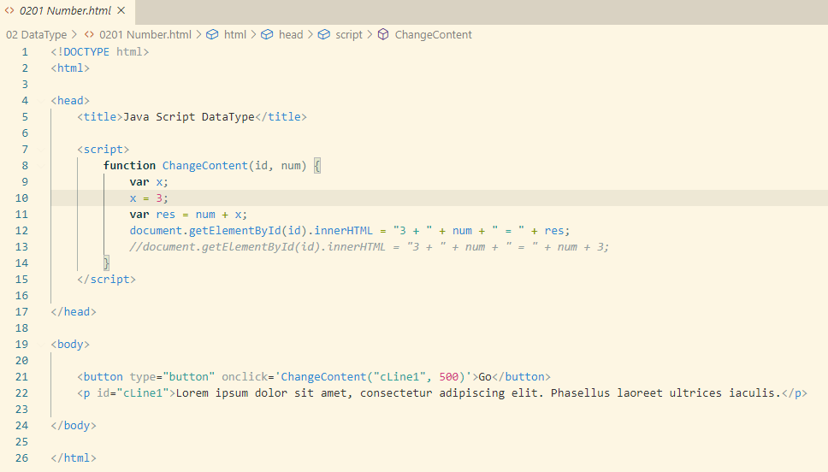

### String

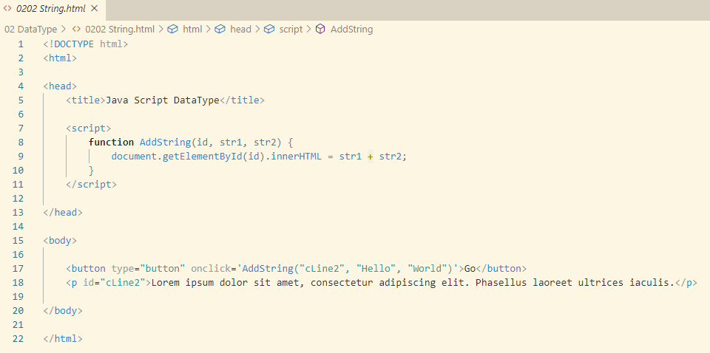

### Arithmetic

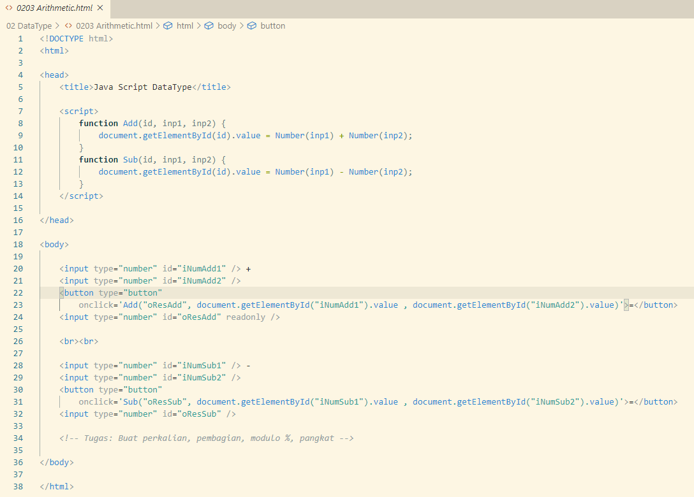

Tugas: Lengkapi Perkalian, pembagian, modulo, dan pangkat

## Syntax

### For Loop

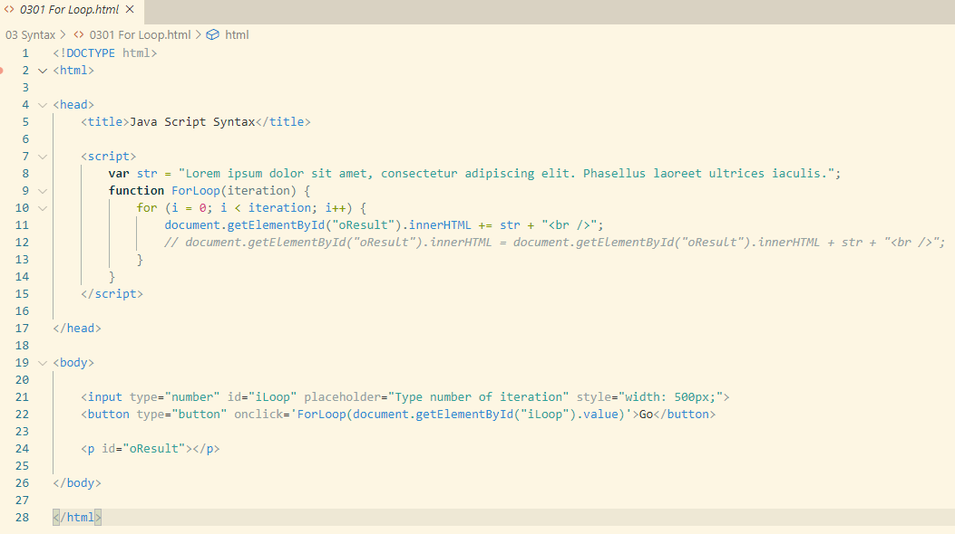

### Array, In Loop

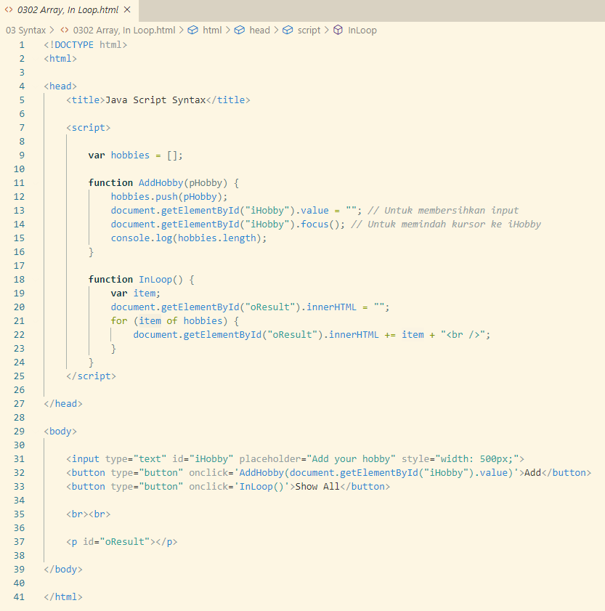

### If Then Else

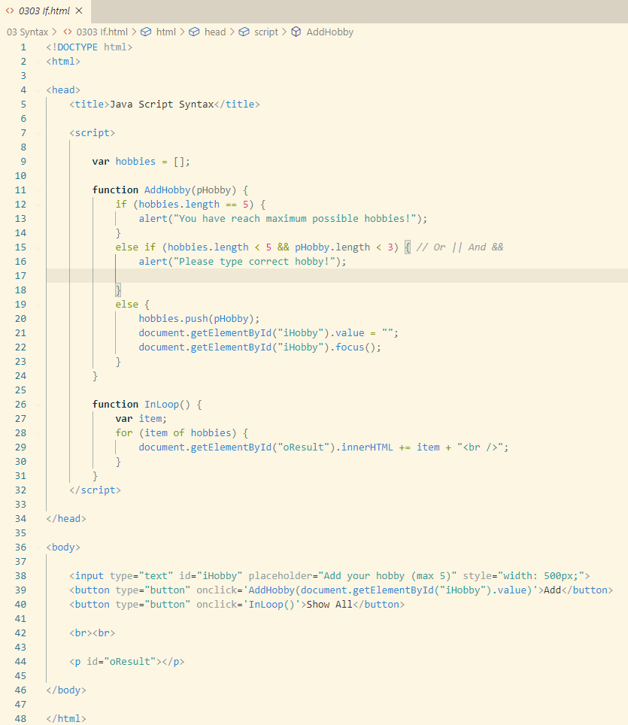

## Object

### Declaration

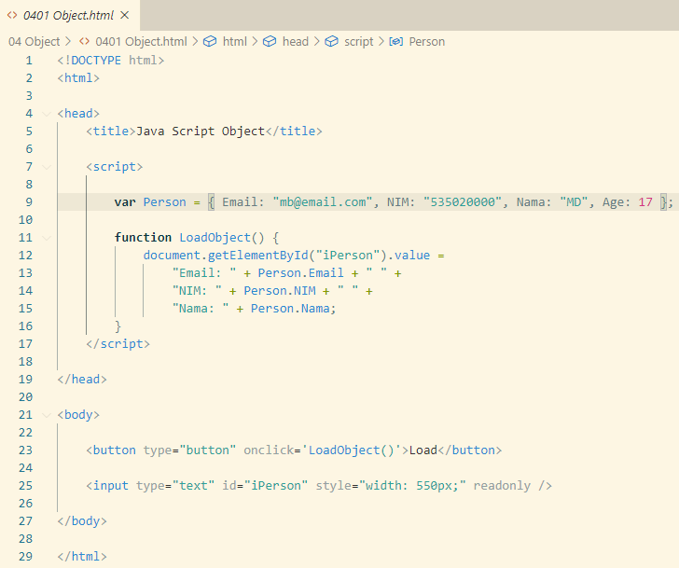

### Creation

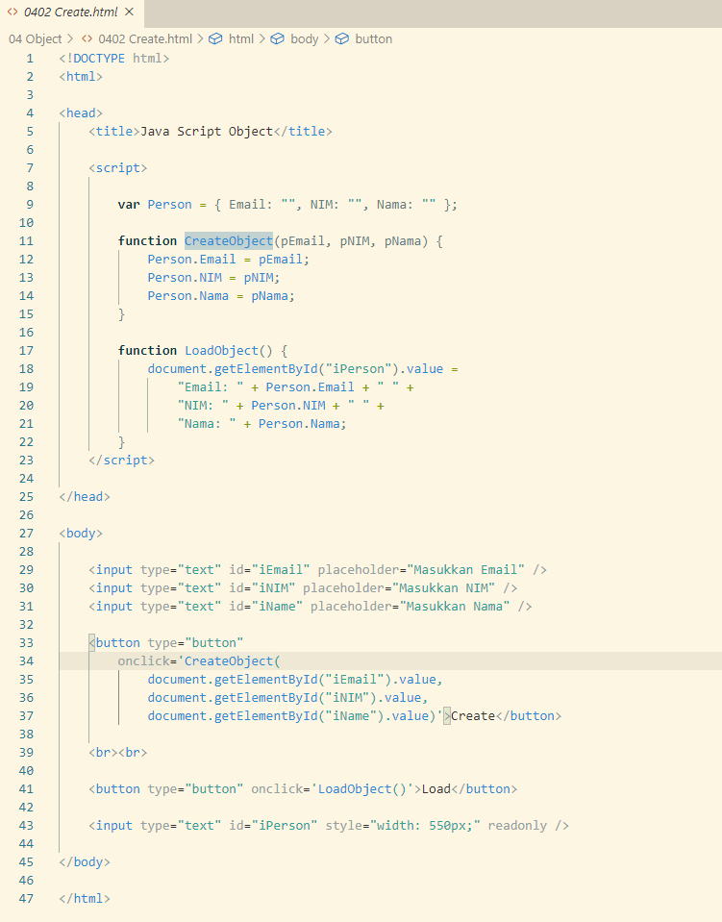

### Method

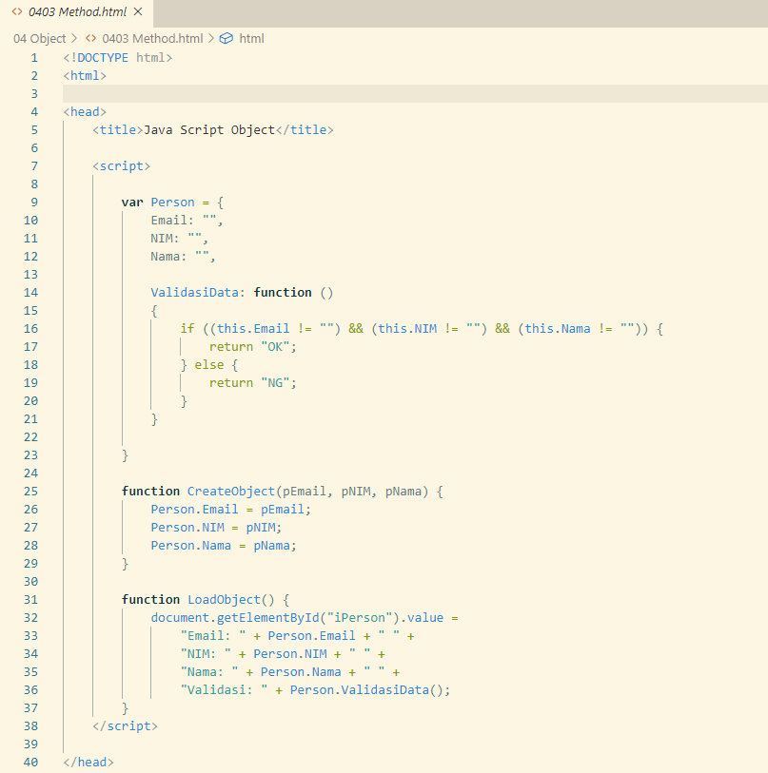

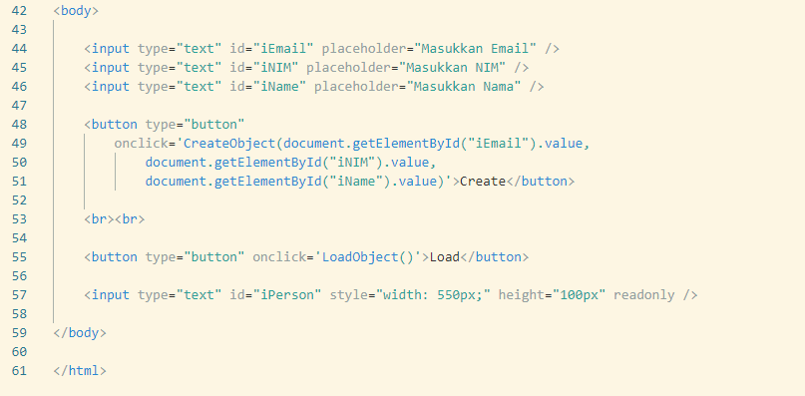

### Constructor

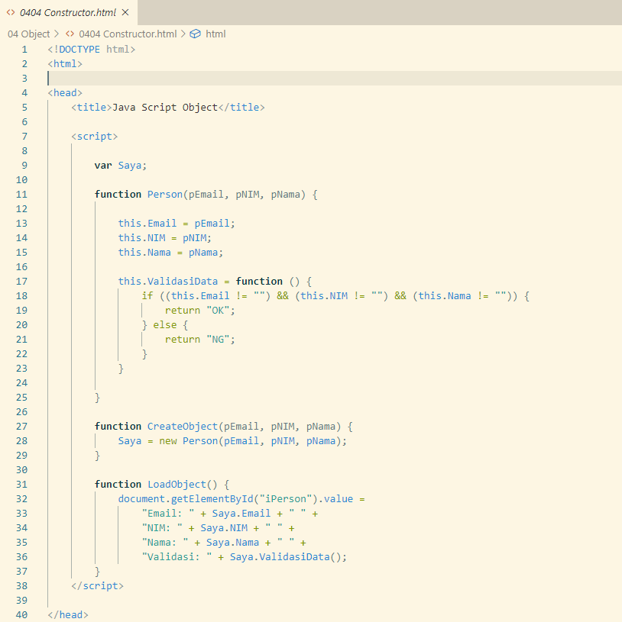

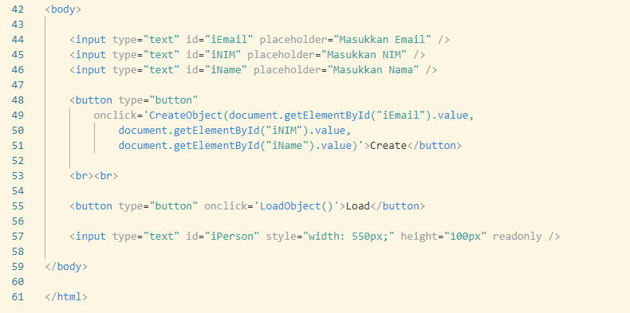

## Invocation Pattern

### Method Invocation 1

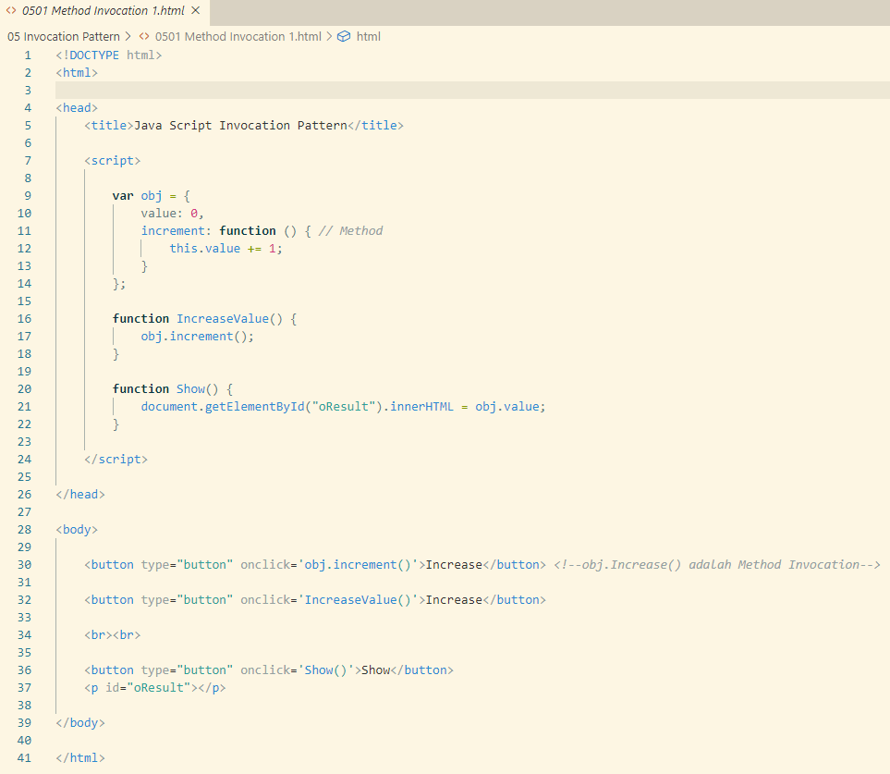

### Method Invocation 2

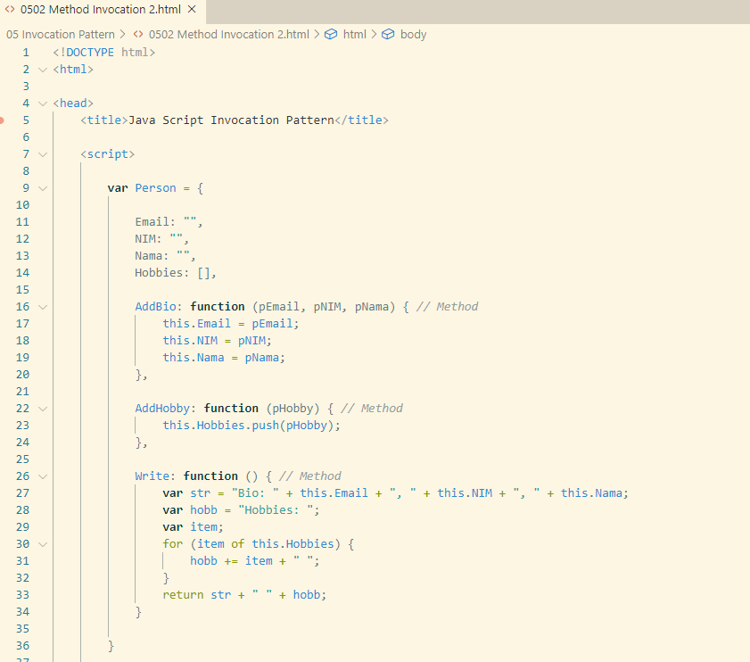

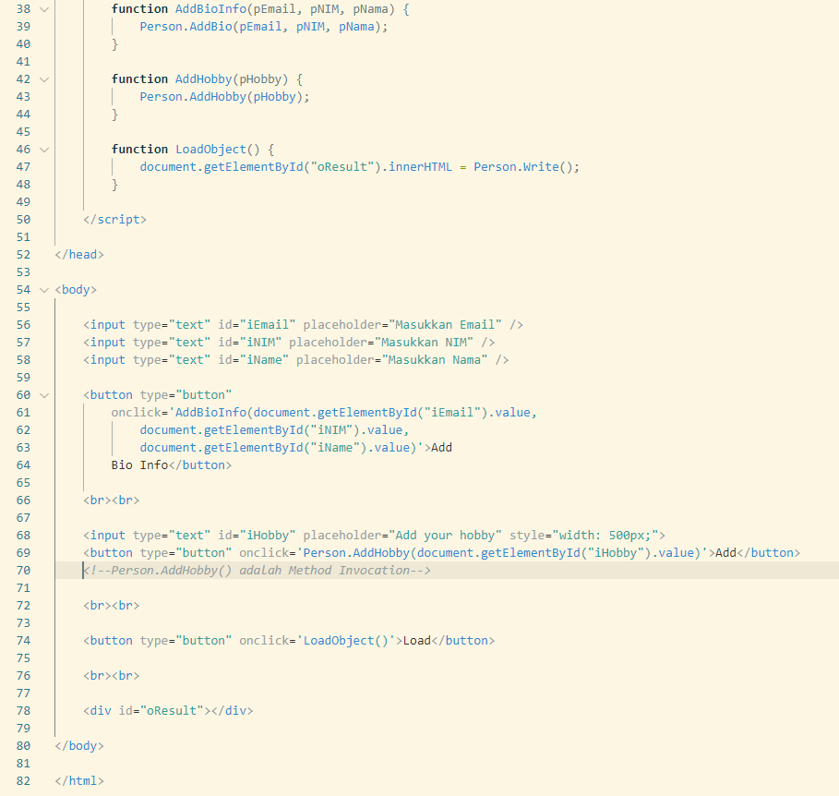

### Function Invocation 1

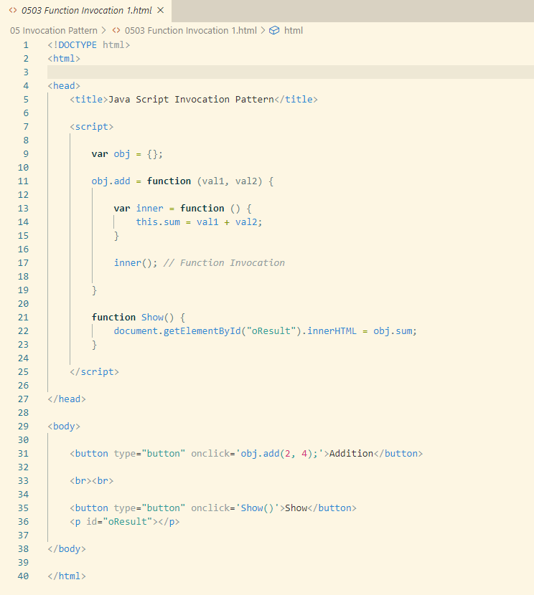

### Function Invocation 2

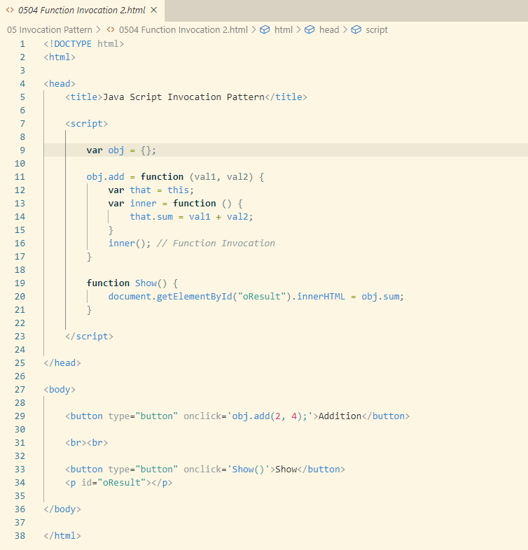

### Constructor Invocation 1

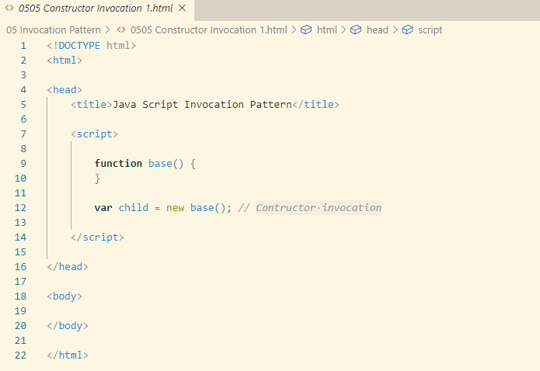

### Constructor Invocation 2

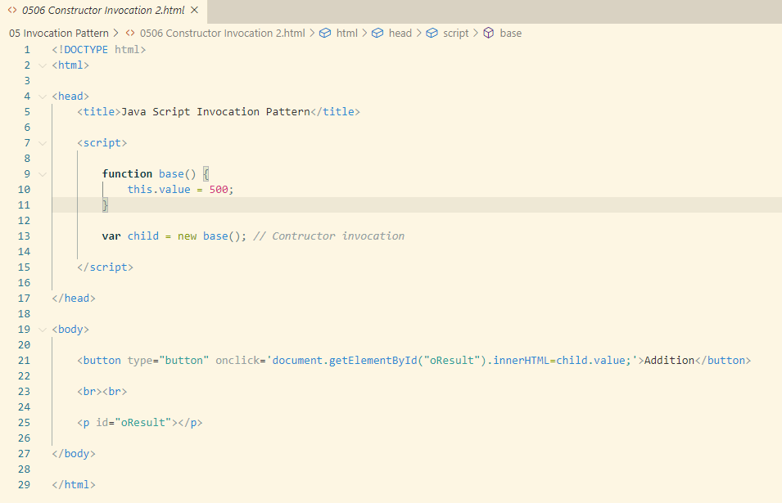

### Apply Invocation

